MARS

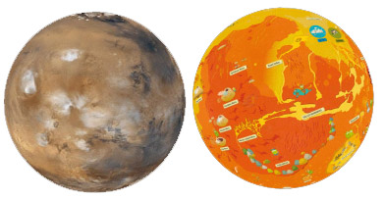

Mars, during its most ancient, warmest period, could have lots of water on the surface. Even today you can see traces of ancient rivers, lakes and probably even seas. However, this water froze billions of years ago. The dry surface has been shaped by winds and frost for the last hundreds of millions of years. Volcanoes, reaching even beyond the upper limit of the dusty atmosphere, are all extinct – or are they perhaps not all dead yet? In some places quite fresh lava flows are visible. So far, neither life nor traces of life have been found on Mars. The main area types of Mars are: the southern, densely cratered areas, northern plains, the canyon system of Mariner Valley, two large volcanic rises, two southern basins and the large polar ice caps.

Body type: planet
Body composition: rocky
Atmosphere: thin CO₂ atmosphere
Liquid: salty water may exist in liquid form under special conditions, however, it boils at few degrees C° because of the low air pressure. It stays liquid in shadowed slopes longer where sunlight does not evaporate it. The ground has ground ice that can become liquid if it receives heat.
Weather: Foggy in depressions and valleys before sunrise. Local to global dust storms during summer. Cloudy near the large volcanoes' bases. Dust devils (miniature tornadoes) common on dark surfaces. It never rains, there are no rain clouds: always dry. The air is always dusty. High UV radiation. Average summer temperature on ground level -50C, at the top of high volcanoes -90C. Windy in lowlands and/or on east-facing slopes of large-scale topographic rises. Typical temperatures are -80°C at dawn and -20°C at noon but warmer during the southern summer. Hottest during the southern summer near noon in the southern hemisphere, up to 25C, Cold in the polar regions, snow at the poles during winter, surface frost during winter and early spring around the polar areas: coldest places at the poles during the dark winter have -130C.
Endogenic features: volcanoes, lava plains, fractures
Exogenic features: ancient, now dry river channels and valleys, gullies on slopes, dunes, ice cap
Cosmogenic features: impact craters
Common features: craters, channels, dunes
Rare features: lava channels, landslides, old river deltas, old, now dry lakes, lava coils
Life limiting parameter: low air pressure, radiation, no liquid water, low temperature
Nomenclature: The main features are named after mythological and biblical places, following the tradition set by Schiaparelli in the 19th century, who created a “mystical and old” world with his names. Large craters are named after scientists, small craters after towns. The Valles Marineris after the Mariner spacecraft.
Highest point: Olympus Mons (approx. 24 km high)
Lowest point: Hellas Basin, a large impact basin mostly filled by sediments
Age: cratered highlands are older than 3.9 billion years, younger volcanic plains and valley networks are about 3.6-3.8 billion years old, outflow channels and some gullies are younger, polar ice, dunes and slope lineae are recent.
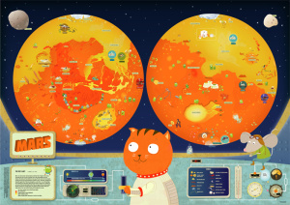Mars map: (Illustrator: Csilla Kőszeghy) The map of Mars is the most detailed, showing the different landforms together with “little green men,” which interact with the geographic landforms and the landers and rovers in funny micro scenes. The map highlights the hemispheric dichotomy with yellow-orange contrast: the northern lowlands (yellow) are smooth and mostly craterless, and are covered by lavas or sediments from an ancient ocean, while the southern hemisphere (orange) is very old, is higher than the northern regions, and has lots of impact craters. The Tharsis Rise is more reddish: it is a volcanic rise with several shield volcanoes and recent lava flows. There are two old, large impact basins in the highlands, shown in yellowish-lighter colours. These may have been large lakes in the past.
Some Martian features, informally referred to by unusual names, are depicted after their informal names (“Swiss Cheese terrain”, “spiders” etc.), which helps to visualize these terms and concepts. The colours refer to different heights but several feature types are shown in perspective-view symbols. Some landforms are emphasized for clarity, such as the Uzboi-Ladon-Margaritifer channel system from Argyre to Chryse.

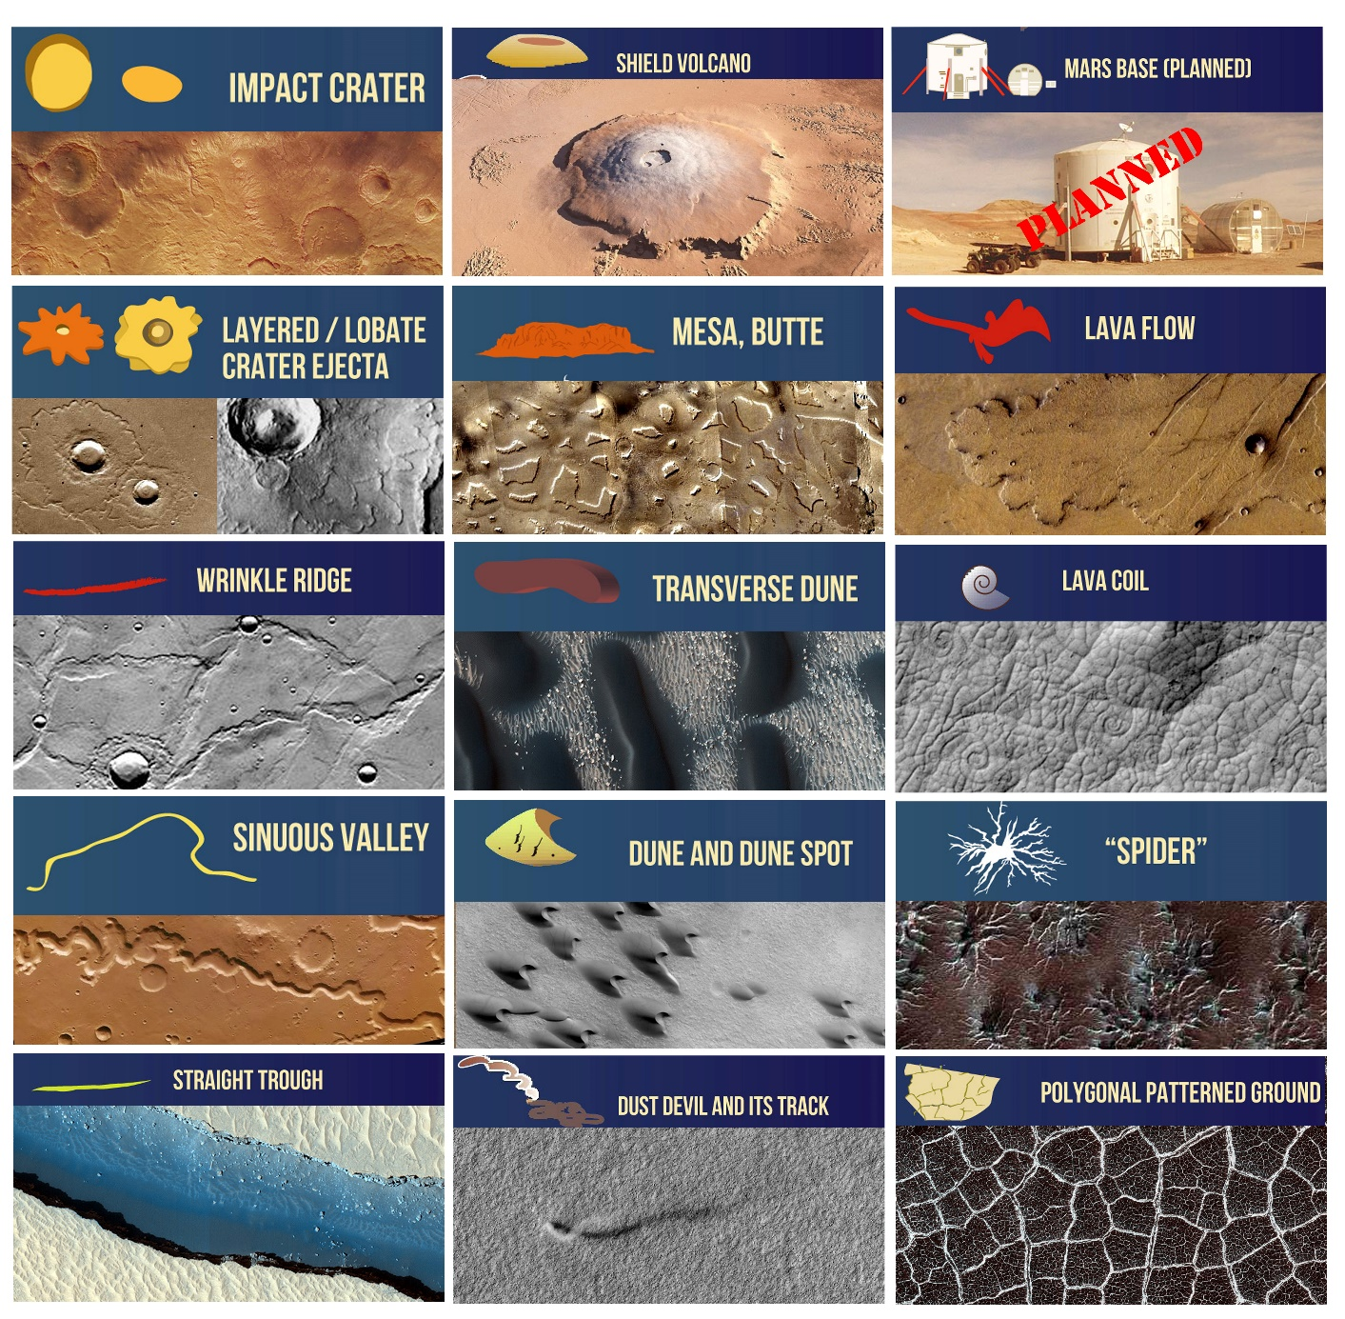
INSTRUCTIONS / MARS
ACTIVITY 1
- Draw the Equator
- Mark the North Pole and South Pole in both hemispheres with letters N and S
- Write the name of the body
ACTIVITY 2 Read the handout, and underline words you don’t understand.
Graphic map. Using the map, draw a generalized (simplified) sketch map, showing the outlines of only the largest and most important features (draw several types of features, e.g., cracks and craters). You can use colours and/or lines.
- Sedimentary or lava
  - The northern lowlands (shown in yellow)
- Impact
  - The southern highlands with lots of craters (shown in orange)
  - Two large impact basins (Argyre Planitia and Hellas Planitia)
- Tectonic (fractures in brittle crust)
  - Valles Marineris trough and its channels
- Volcanic
  - Olympus Mons and other nearby three volcanoes and Elysium Mons volcano
- Glacial (ice related)
  - The two bright polar caps
- Most famous landers: Viking 1-2, Phoenix, Spirit, Opportunity, Curiosity

ACTIVITY 3 Your landing site. Where would you land? Which place you find the most exciting for exploration? Find YOUR landing site. Mark it with a symbol. Name your landing site (s). Write down the names next to the symbol.
ACTIVITY 4 Names. After the graphic part is finished, create the nomenclature: write the names of the features you have drawn next to the feature itself. Write three names (you can add more later) onto the map. You can use different colours or letters for each feature type (e.g., capital letters for continents, red colour for the lava channel etc. -- be consistent).
ACTIVITY 5 Make up a weather forecast for "tomorrow", based on the Weather information in the handout. Choose at least three places, and show weather data: display the min/max temperature in your unit with LARGE numbers. Consider that on towards the poles it is colder. Next to the numbers, show the weather with a graphic symbol you design: clear (sunny), cloudy, rainy, foggy or any interesting, special weather phenomenon you learn from the handout. Find min/max temperature data on the map's control desk and additional information on the handout.
ACTIVITY 6 Design a flag for the planet or moon, and draw it on the map, based on the characteristics of the body (weather, colour, geology etc.).
ACTIVTY 7 Draw a map legend where YOUR symbols are explained on the map. You may group them by process (e.g., exogenic (atmospheric, aeolian), endogenic (volcanic, tectonic) and impact processes). Write down the title “LEGEND” and explain your symbols and indicate which feature it corresponds to.

